Date | 01/11/2025
Time id | NM2025TMID06951
Project name | Laptop Request Catalog Item
Maximum mark | 4 marks

PROJECT DESIGN PHASE 2
TECHNOLOGY STACK (ARCHITECTURE & STACK)
The technical architecture for the Laptop Request Catalog Item project is designed to simplify and automate the process of requesting, approving, and fulfilling laptop requests within an organization. It ensures seamless workflow integration, user-friendly interfaces, and secure data management. The architecture follows a three-tier model comprising the Presentation Layer, Application Layer, and Data Layer, enhanced by automation, integration, and reporting modules.

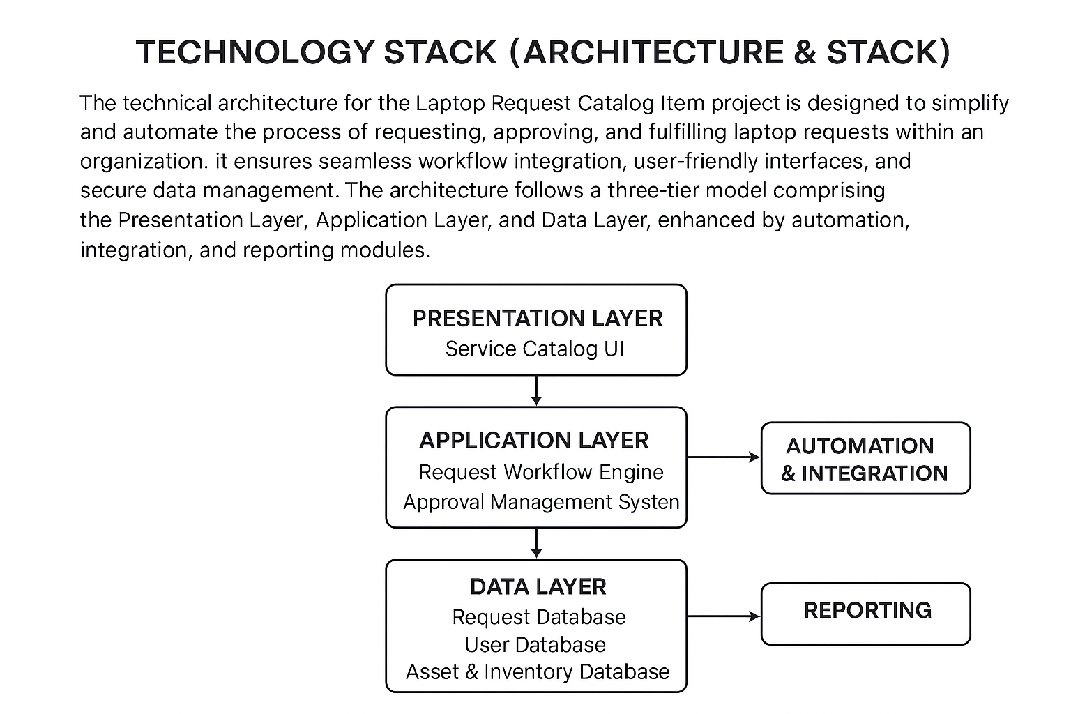

Components and Technologies:

Layer | Components | Technologies / Tools
1. Presentation Layer | - Service Catalog UI- Request Form Interface- Status Tracking Dashboard- Notification Center | HTML5, CSS3, JavaScript, React.js / Angular, REST APIs
2. Application Layer | - Request Workflow Engine- Approval Management System- Notification Service- Integration Middleware | Python (Flask / Django), Node.js, Express.js, ServiceNow API
3. Data Layer | - Request Database- User Database- Asset & Inventory Database- Audit Log Database | MySQL, PostgreSQL, MongoDB, Firebase
4. Automation & Integration Layer | - Workflow Automation- Integration with HR & ITSM systems- Auto-notification Service | Python, Power Automate, ServiceNow Workflows, Webhooks
5. Security & Infrastructure Layer | - Authentication & Authorization- Data Encryption- Cloud Deployment- Backup & Recovery | OAuth 2.0 / JWT, SSL/TLS, AWS / Azure, Docker, Kubernetes
6. Monitoring & Reporting Layer | - Request Reports- Inventory Insights- System Monitoring- Performance Metrics Dashboard | Grafana, Power BI, Prometheus, Kibana

